

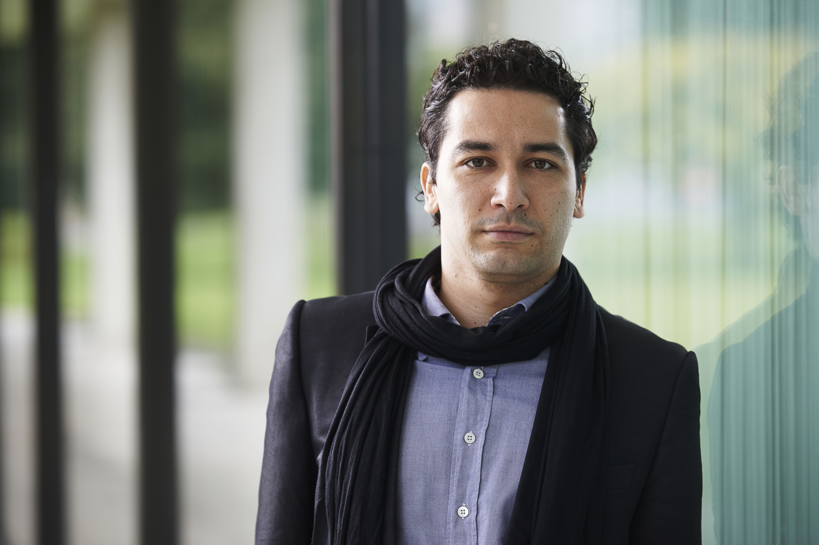

ANDRÉS OROZCO-ESTRADA

Andrés Orozco-Estrada was born in Medellín (Colombia) and trained in Vienna. In September 2014, he took up the positions of Music Director of the Houston Symphony and Chief Conductor of the Frankfurt Radio Symphony Orchestra. From the 2015/16 season, he also became the Principal Guest Conductor of the London Philharmonic Orchestra. He previously served as Principal Conductor of the Tonkünstler Orchestra, with whom he developed a highly successful musical partnership from 2009 to 2015.

Andrés Orozco-Estrada conducts many leading orchestras worldwide, including the Vienna Philharmonic, the Santa Cecilia Orchestra in Rome, the Orchestre National de France, the Dresden Staatskapelle, the Leipzig Gewandhaus Orchestra, the Vienna Symphony and the Mahler Chamber Orchestra, as well as the orchestras of Philadelphia, Pittsburgh, Cleveland and Chicago. In the summer of 2014, he made his debut at Glyndebourne Festival Opera conducting Don Giovanni, for which he was immediately re-invited to conduct La Traviata in 2017. Following a thrilling début the previous year, summer 2016 marked his return to the Salzburg Festival with Nicolai's opera Il Templario and – in place of Nikolaus Harnoncourt – Beethoven's Ninth with the Concentus Musicus Wien.
His engagements for the 2016/17 season feature débuts with the San Francisco Symphony in April and the Berlin Philharmonic in May. Orozco-Estrada and the Frankfurt Radio Symphony will give a series of concerts as orchestra-in-residence in Vienna and Salzburg, in addition to undertaking tours to Budapest, Warsaw, Monte Carlo, the Dresden Music Festival and across Spain. He will also accompany Colombia's outstanding youth orchestra, the Filarmónica Joven de Colombia, on their first European tour, conducting eight concerts in Berlin and Stuttgart, at the Rheingau Music Festival, at the Mecklenburg-Vorpommern Festival and at the styriarte in Graz. Furthermore, he will embark on his first European tour with the Houston Symphony.
Recent CDs released on Pentatone are generating a great deal of attention and include Stravinsky’s The Rite of Spring and Richard Strauss’s Ein Heldenleben and Macbeth, both with the Frankfurt Radio Symphony. He has recorded the Dvořák symphonies 6, 7, 8 and 9 with the Houston Symphony. Further recordings are in preparation. Complete symphonic recordings of Brahms and Mendelssohn are also available.

Andrés Orozco-Estrada began his musical studies on the violin before receiving his first conducting lessons at the age of 15. In 1997, he moved to Vienna where he joined the conducting class of Uroš Lajovic, pupil of the legendary Hans Swarowsky, at the renowned Vienna Music Academy. Orozco-Estrada currently lives in Vienna.

www.orozcoestrada.com
March 2017

*

Saison 2016|17
General Management: Nicholas Mathias|Derek Chandruang, IMG Artists

Tel: +44 (0)20 7957 5800 | +44 (0) 20 7957 5806

Email: nmathias@imgartists.com / dchandruang@imgartists.com
Media + PR: Birgit Heinemann, PRomotio artis, Tel.: +49 (0)174 727 8040
Email: heinemann@promotioartis.de

